Lesson 22 – Analyzing Log Files using AdvantageScope

DRAFT
AdvantageScope is a data visualization tool for NetworkTables, WPILib data logs, and Driver Station logs. It is a programmer’s tool (rather than a competition dashboard) and can be used to debug real or simulated robot code from a log file or live over the network.

In the lessons so far we have learned about logging and generating log files. AdvantageScope is a WPI application that allows you to download these log files to review the robot performance. These log files are stored in the Romi simulation in a file called Logs. They can also be downloaded from the RoboRio or the new Systemcore computer using FileZilla.

This lesson is applicable to any platform independent of where the files came from. We will not need the Romi, but instead you can use any of the log files from all the 2026 competitions. These are available here: 2026 Log Files These are compressed (zip) files, so pick ones you want, extract them and store them on your computer. I used Beach Blitz 2026 which are on this google drive. If you want to use those, download them on to the computer you are using.

https://drive.google.com/drive/folders/1DaYxIzQA9G6uk-T4COUqrsOERY00tWz6
Path = BCR Files\Season Specific Files\2026 Rebuilt\Programming\Logfiles from competitions

The full documentation of AdvantageScope is available here: AS Documentation

You should look through this to at least know what are the capabilities and where to get more info.

We will now go through one example which will show how to read a log file and display a robot’s path.

In Visual Studio Code, press Ctrl+Shift+P and type WPILib or click the WPILib logo in the top right to launch the WPILib Command Palette. Select Start Tool, then select AdvantageScope. You can also open any supported log file in AdvantageScope using a standard file browser.

(AdvantageScope should already be downloaded on the lab computers. If it is not on your computer, download it here; AS download ).

On the AS window, click File, Open Log(s), and select the file that you want to use.
In the left column, you will see all of the different fields that have been logged. Any field that you want to plot, you left click on and drag to the axis that you are interested in viewing.

Here is an example: Open WPILIB_20261101_221521_CAMIS_E2.wpilog which is from the 2026 Beach Blitz competion. We will show the robot path during the match.
Select the 2D Field from the top and the 2026 Field as the source. Your AS screen should like l
this:
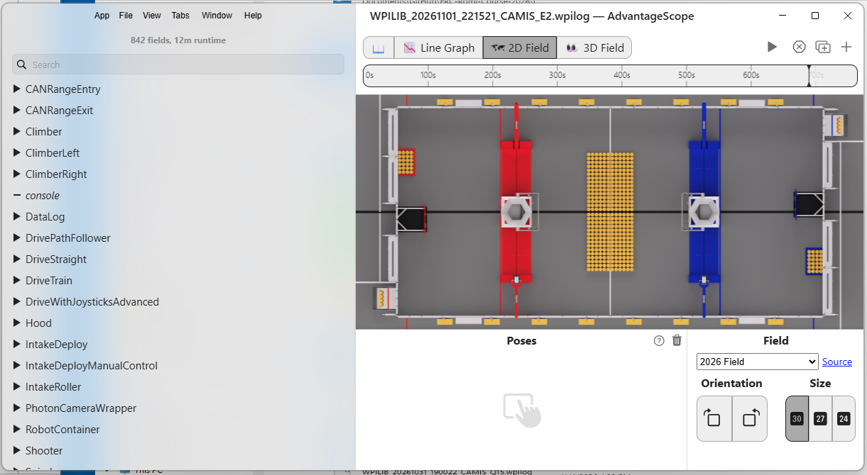

The left column displays all the parameters in the log file that we could display. Since we want to see the robot path, select DrivePathFollower and then curPose2d. Drag the curPose2d under the Poses label. You are now ready to see the position of the robot vs. time on this display. The log file is generated once the robot is placed on the field and turned on, so there is a lot of time when the robot is not moving. On the time bar, slide the cursor until you see the robot start moving. (About 500s on this example) Then push the play triangle to see the robot’s trajectory during the competition.

References:
https://docs.wpilib.org/en/stable/docs/software/dashboards/advantagescope.html
https://docs.advantagescope.org/

